DB user Privileges

COHDSE182F-007

Minidu Wickramaarchchi

* Setting MYSQL

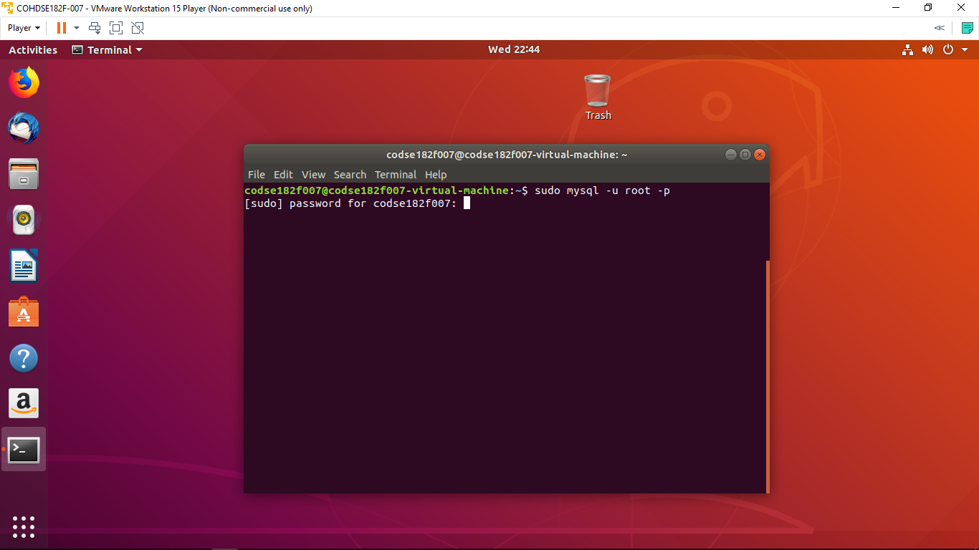

* Creating database

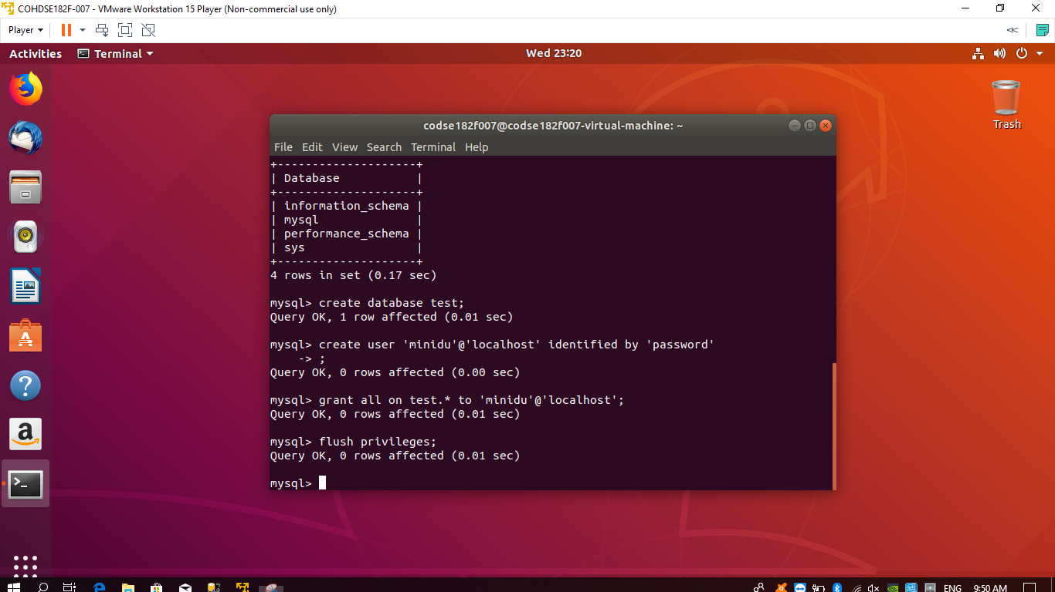

* Checking the db which we created

